Collaring lions at Nambiti Reserve is important for the conservation efforts focused on this specific ecosystem. Nambiti Reserve has its own unique environmental factors and wildlife dynamics, so it's crucial to gather targeted and localized data to guide conservation strategies. When lions are collared, researchers receive detailed insights into the behavior, movement patterns, and territorial dynamics of the Nambiti lion population. This information is key for creating and implementing conservation measures that combat the challenges of Nambiti's landscape. Additionally, collaring lions at this reserve helps monitor how they interact with other wildlife, contributing to a better understanding of the ecological balance in Nambiti. In the end, collaring lions at Nambiti Reserve is a key part of the conservation initiatives needed to protect the biodiversity and ecological well-being of this unique wilderness area.

*Collaring the Big Cats of South Africa*

My primary goal in Nambiti is to improve the game reserve’s ability to identify and track these lions. This will ensure a healthy ecological balance, a thriving lion population, and safe populations of surrounding wildlife for years to come. Over the next couple of months, my classmates and I will plan, work on, and finish our projects. There are other projects like building a schoolhouse, a girl’s orphanage, and supplying years' worth of food. However, for my part in the project, I'll be fundraising to carry out lion collaring for the Nambiti Game Reserve. The project's costs are distributed across various factors, with the primary expenses being the lion collar, vet fees, satellite fees, shipping, and monitoring. Securing these essential resources is crucial to transforming our project into reality.

**Per Lion Collaring**

|  |  |  |  |  |  |
| --- | --- | --- | --- | --- | --- |
| Lion Collar | Vet Fees | Transportation | Satellite Fees | Shipping/Monitoring | Total |
| $3000 | ~$900 | ~$700 | ~$250 | $150 | $5000 |

In May 2024, my classmates and I will embark on a project to implement our projects in South Africa. This endeavor offers us the opportunity to gain valuable experience in leadership, communication, and advance our understanding of culture. Specifically, I am dedicated to making a positive impact on the Nambiti Game Reserve and its wildlife population. By understanding and protecting

[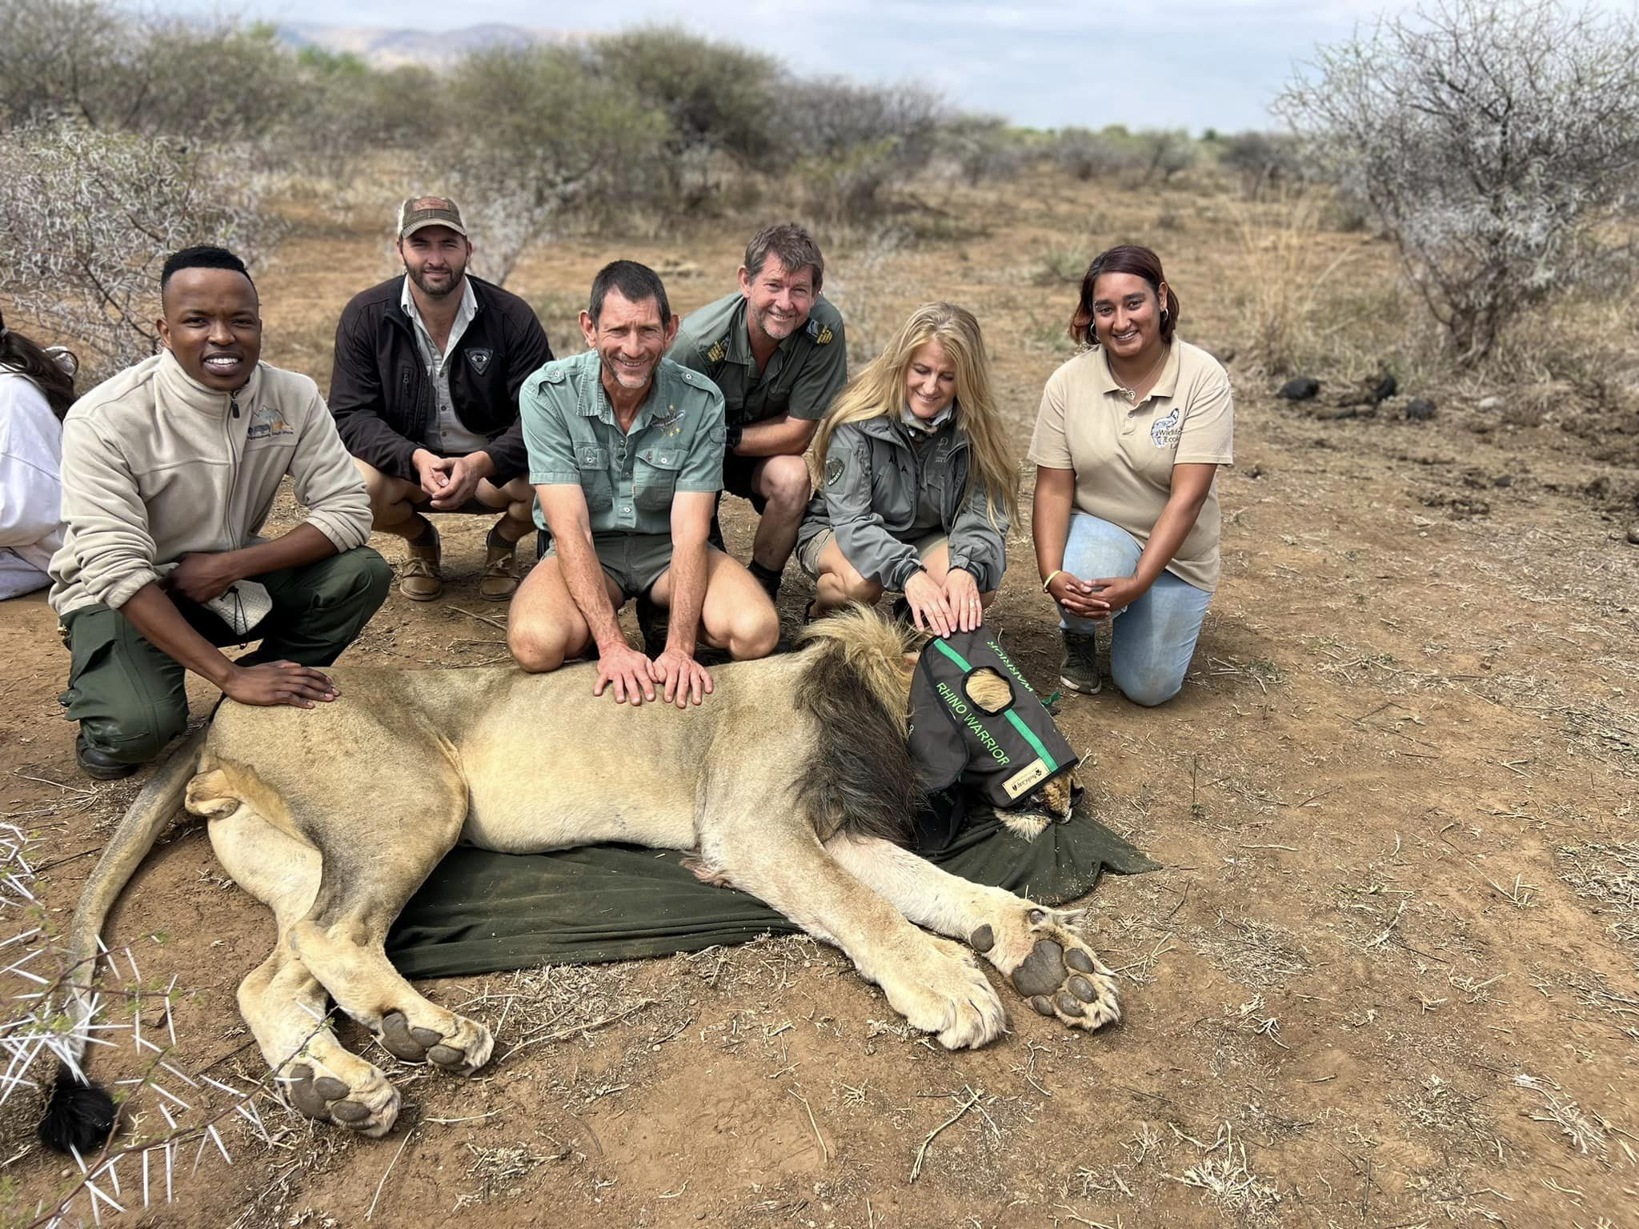](https://www.google.com/url?sa=i&url=https%3A%2F%2Fpilanesbergwildlifetrust.co.za%2Flion-collaring-in-black-rhino-reserve%2F&psig=AOvVaw3wafJP4KNLPyGEXITRFXzc&ust=1706321065692000&source=images&cd=vfe&opi=89978449&ved=0CBMQjRxqFwoTCIi4h737-YMDFQAAAAAdAAAAABAD)

these magnificent creatures, I believe that

providing them with proper identification,

space, and respect could contribute to their

ability to thrive and, in turn, foster more

generations of Lions and other wildlife. If

you help me reach the $5000, you’re

allowing me and my classmates to buy a

collar, hire a vet, get a helicopter, trucks,

and fuel, and pay for the safe sedation and

collaring of a lion. Your sponsorship would

greatly enhance our ability to make a

meaningful difference for both the animals

and people of South Africa, improving their

quality of life.